Recursive Function in Python
A recursive function is a function that calls itself during its own execution. It solves a complex problem by breaking it down into smaller, simpler sub-problems of the same type, until it reaches a simple base case that can be solved directly.
- Base Case – The stopping condition. Without this, the function recurses forever and causes a Stack Overflow error.
- Recursive Case – The part where the function calls itself with a smaller/simpler input.
- Progress toward Base Case – Each recursive call must bring the problem closer to the base case.

Types of Recursion

1. Direct Recursion
Function calls itself directly
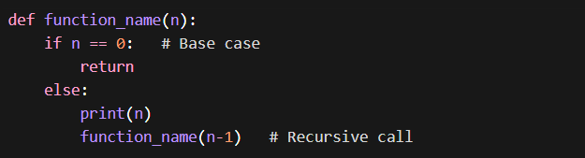

2. Indirect Recursion
Function calls another function, which calls the first function
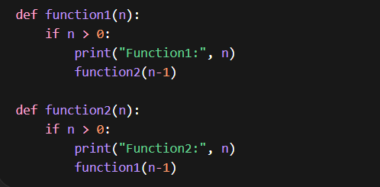

3. Tail Recursion
Recursive call is the last operation
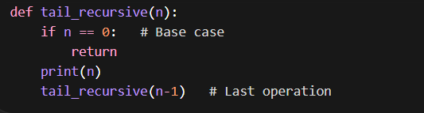

4. Non-Tail Recursion
Recursive call is not the last operation
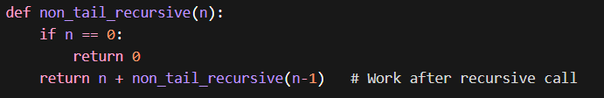
Why to use Recursive function:

Basic Structure
def function_name():
if condition: # Base case (stopping condition)
return value
else:
return function_name(smaller_problem)
Example:
def factorial(n):
# Base Case
if n == 0 or n == 1:
return 1
# Recursive Case
return n * factorial(n - 1)
# Test
print(factorial(5)) # Output: 120
print(factorial(0)) # Output: 1
print(factorial(1)) # Output: 1

Function Call | Returns
factorial(5) | 5 × factorial(4) → 5 × 24 = 120
factorial(4) | 4 × factorial(3) → 4 × 6 = 24
factorial(3) | 3 × factorial(2) → 3 × 2 = 6
factorial(2) | 2 × factorial(1) → 2 × 1 = 2
factorial(1) | 1 (Base Case — stops here)

Advantage & Disadvantage:
Advantages ✅ | Disadvantages ❌
Clean, concise code for complex problems | Higher memory usage (call stack)
Natural fit for tree, graph problems | Slower due to function call overhead
Easy to model mathematical definitions | Risk of StackOverflow without base case
Divide-and-conquer problems become simple | Harder to debug and trace

Questions:
- Sum of Nature Number?
- Power of a Number (X^N)
- Reverse a String
- Count Digits in a Number
- Fibonacci Series
- Palindrome Check
- Merge Sort
- Quick Sort

Decorator Functions in Python:
In Python, a decorator is a function that is used to modify or extend the behavior of another function without changing its original source code.
In simple terms, a decorator wraps another function and adds some additional functionality before or after the execution of that function.

Key Idea
- Original function → unchanged
- Decorator → adds new behavior
- Result → enhanced function
Why Use Decorators?
Decorators are useful for:
✔ Logging
✔ Authentication (checking user access)
✔ Measuring execution time
✔ Debugging
✔ Code reusability
- Code Reusability
- Clean and Readable Code
- Avoid Repeated Code

Answer:

- Sum of Natural Number:
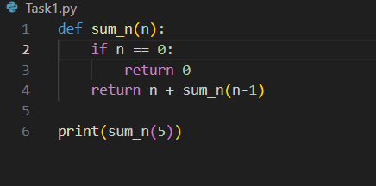
- Power of a Number (X^N)

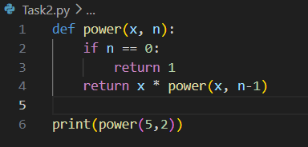
- Reverse a String

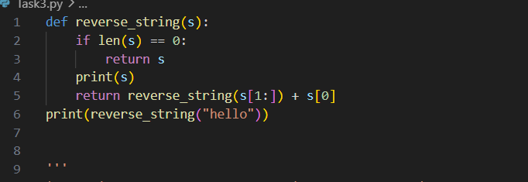
- Count Digits in a Number
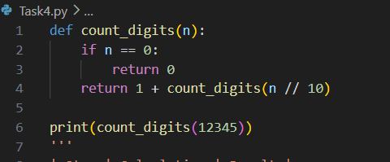
- Fibonacci Series (nth number)

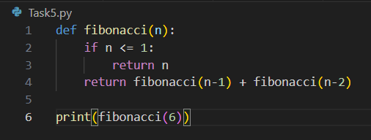

- Palindrome Check

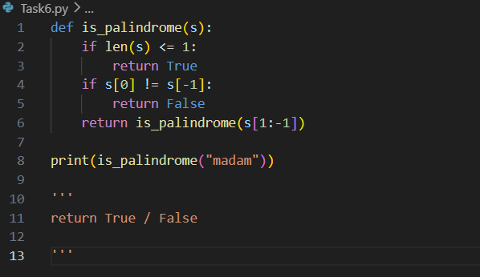
- Merge Sort

